Lab 2.1.4.7 Establishing a Console Session with Tera Term

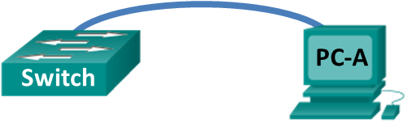

1. Objectives

Part 1: Access a Cisco Switch through the Serial Console Port

Part 2: Display and Configure Basic Device Settings

1. Background / Scenario

Various models of Cisco routers and switches are used in all types of networks. These devices are managed using a local console connection or a remote connection. In this lab, you will learn how to access a Cisco device via a direct local connection to the console port, using the terminal emulation program called **Tera Term**. Using **Tera Term** is the most basic way to access a router for checking or changing its configuration. After you have established a console connection with the Cisco device, you can display or configure device settings. You will only display settings and configure the clock in this lab.

* 1. 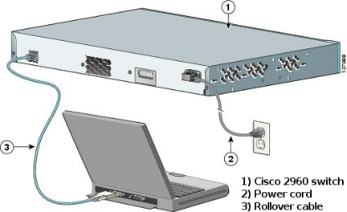Connect a Cisco switch and computer using a rollover console cable.
     1. Connect the rollover console cable to the RJ-45 console port of the switch.
     2. Connect the other cable end to the serial COM port on the computer.
     3. Turn on the Cisco switch and computer.
  2. Configure Tera Term to establish a console session with the switch.

**Tera Term** is a terminal emulation program. This program allows you to access the terminal output of the switch. It also allows you to configure the switch.

1. Start **Tera Term** by clicking the **Windows Start** button located in the task bar. Locate **Tera Term** under **All Programs**.
2. In the New Connection dialog box, click the **Serial** radio button. Verify that the correct COM port is selected and click **OK** to continue.

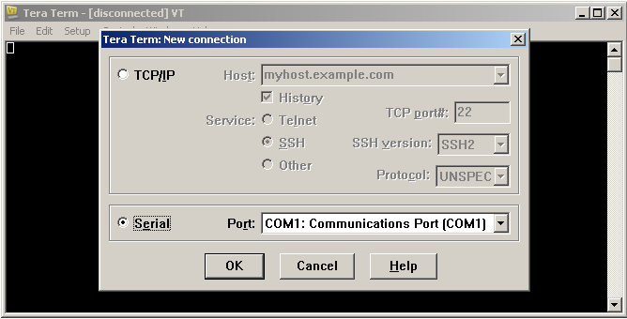

1. From the **Tera Term** **Setup** menu, choose the **Serial port**… to verify the serial settings. The default parameters for the console port are **9600 baud**, **8 data bits**, **no parity**, **1 stop bit**, and **no flow control**. The **Tera Term** default settings match the console port settings for communications with the Cisco IOS switch.

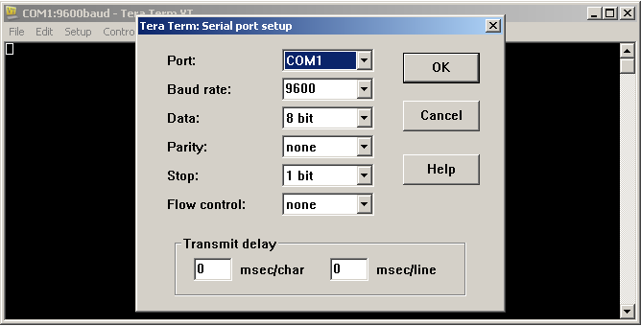

* + 1. When you can see the terminal output, you are ready to configure a Cisco switch. The following console example displays the terminal output of the switch while it is loading.

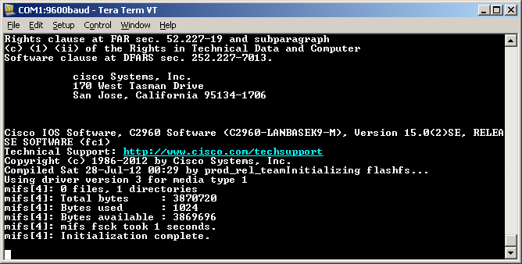

* 1. Display and Configure Basic Device Settings

In this section, you are introduced to the user and privileged executive modes. You will determine the IOS version, display the clock settings, and configure the clock on the switch.

* + 1. After the switch has completed its startup process, the following message is displayed. Enter **n** to continue**.**

**Would you like to enter the initial configuration dialog? [yes/no]: n**

**Note**: If you do not see the above message, please contact your instructor to reset your switch to the initial configuration.

* + 1. While you are in the user EXEC mode, display the IOS version for your switch.
  1. Display the IOS version and other useful switch information.

Use the **show version** command to display the IOS version that the switch is running, along with other useful information. Again, you will need to use the spacebarto advance through the displayed information.

Switch> **show version**

Cisco IOS Software, C2960 Software (C2960-LANBASEK9-M), Version 15.0(2)SE, RELEASE SOFTWARE (fc1)

Technical Support: http://www.cisco.com/techsupport

Copyright (c) 1986-2012 by Cisco Systems, Inc.

Compiled Sat 28-Jul-12 00:29 by prod_rel_team

ROM: Bootstrap program is C2960 boot loader

BOOTLDR: C2960 Boot Loader (C2960-HBOOT-M) Version 12.2(53r)SEY3, RELEASE SOFTWARE (fc1)

Switch uptime is 1 hour, 38 minutes

System returned to ROM by power-on

**System image file is "flash:/c2960-lanbasek9-mz.150-2.SE.bin"**

This product contains cryptographic features and is subject to United

States and local country laws governing import, export, transfer and

use. Delivery of Cisco cryptographic products does not imply

third-party authority to import, export, distribute or use encryption.

Importers, exporters, distributors and users are responsible for

compliance with U.S. and local country laws. By using this product you

agree to comply with applicable laws and regulations. If you are unable

to comply with U.S. and local laws, return this product immediately.

A summary of U.S. laws governing Cisco cryptographic products may be found at:

http://www.cisco.com/wwl/export/crypto/tool/stqrg.html

If you require further assistance please contact us by sending email to

export@cisco.com.

cisco WS-C2960-24TT-L (PowerPC405) processor (revision R0) with 65536K bytes of memory.

Processor board ID FCQ1628Y5LE

Last reset from power-on

1 Virtual Ethernet interface

24 FastEthernet interfaces

2 Gigabit Ethernet interfaces

The password-recovery mechanism is enabled.

64K bytes of flash-simulated non-volatile configuration memory.

Base ethernet MAC Address : 0C:D9:96:E2:3D:00

Motherboard assembly number : 73-12600-06

Power supply part number : 341-0097-03

Motherboard serial number : FCQ16270N5G

Power supply serial number : DCA1616884D

Model revision number : R0

Motherboard revision number : A0

Model number : WS-C2960-24TT-L

System serial number : FCQ1628Y5LE

Top Assembly Part Number : 800-32797-02

Top Assembly Revision Number : A0

Version ID : V11

CLEI Code Number : COM3L00BRF

Hardware Board Revision Number : 0x0A

Switch Ports Model SW Version SW Image

------ ----- ----- ---------- ----------

* 1 26 WS-C2960-24TT-L 15.0(2)SE C2960-LANBASEK9-M

* + 1. Which IOS image version is currently in use by your switch?

____________________________________________________________________________________

* 1. Configure the clock.

As you learn more about networking, you will see that configuring the correct time on a Cisco switch can be helpful when you are troubleshooting problems. The following steps manually configure the internal clock of the switch.

* + 1. Display the current clock settings.

Switch> **show clock**

*00:30:05.261 UTC Mon Mar 1 1993

* + 1. The clock setting is changed from within the privileged EXEC mode. Enter the privileged EXEC mode by typing **enable** at the user EXEC mode prompt.

Switch> **enable**

* + 1. Configure the clock setting. The question mark (?) provides help and allows you to determine the expected input for configuring the current time, date, and year. Press Enter to complete the clock configuration.

Switch# **clock set ?**

hh:mm:ss Current Time

Switch# **clock set 16:28:00 ?**

MONTH Month of the year

<1-31> Day of the month

Switch# **clock set 16:28:00 Aug 21 ?**

<1993-2035> Year

Switch# **clock set 16:28:00 Aug 21 2019**

Switch#

*Aug 21 16:28:00.000: %SYS-6-CLOCKUPDATE: System clock has been updated from 00:31:43 UTC Mon Mar 1 1993 to 16:28:00 UTC Wed Aug 21 2019, configured from console by console.

* + 1. Enter the **show clock** command to verify that the clock setting has updated.

Switch# **show clock**

16:28:07.205 UTC Wed Aug 21 2019